Project Name : Trends in Gender-Based Violence and Child Protection in Bangladesh  
  
Faiza Rahman   
  
Violence against women and children in Bangladesh, encompassing physical and sexual violence, child abuse, and child marriage, persists as a critical issue, driven by factors such as social stigma, weak legal enforcement, and economic vulnerability, despite increasing public awareness and policy initiatives, with rising reports of rape and child abuse observed from 2018 to 2022. Data for this study were collected from the Bangladesh Bureau of Statistics, Ain o Salish Kendra, BRAC, UNICEF, and media outlets. Key variables analyzed include physical and sexual violence cases, child abuse, child marriage, reported rape cases, and awareness campaign reach. Statistical analysis was used to examine yearly trends from 2018 to 2022, including percentage changes and regional differences inviolence rates.

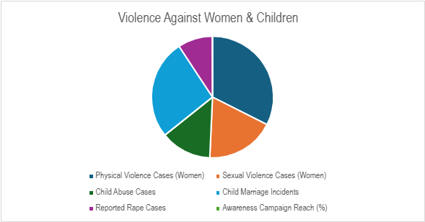

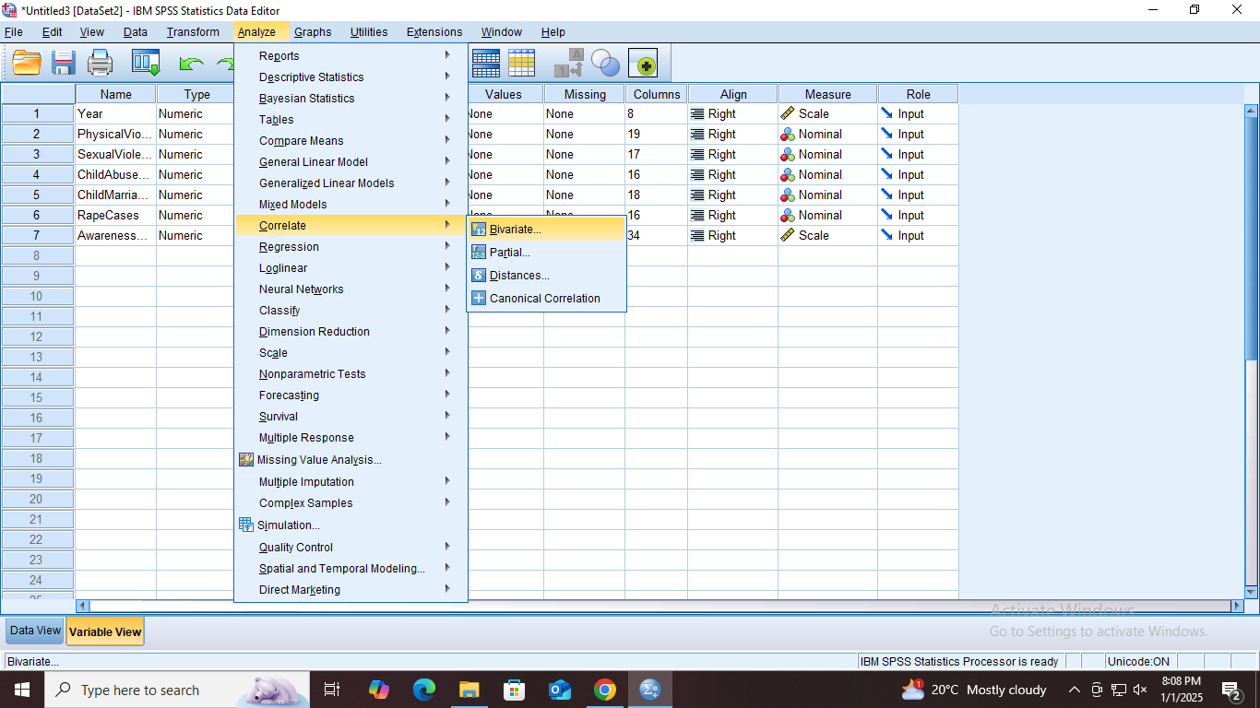

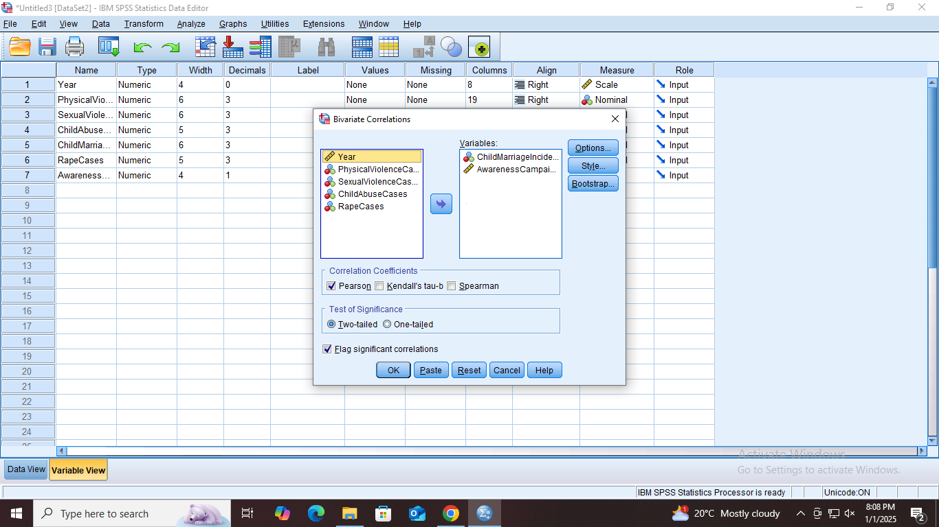

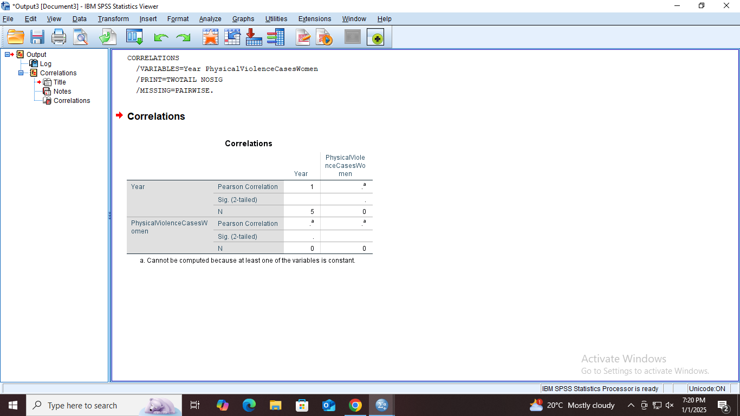  
  


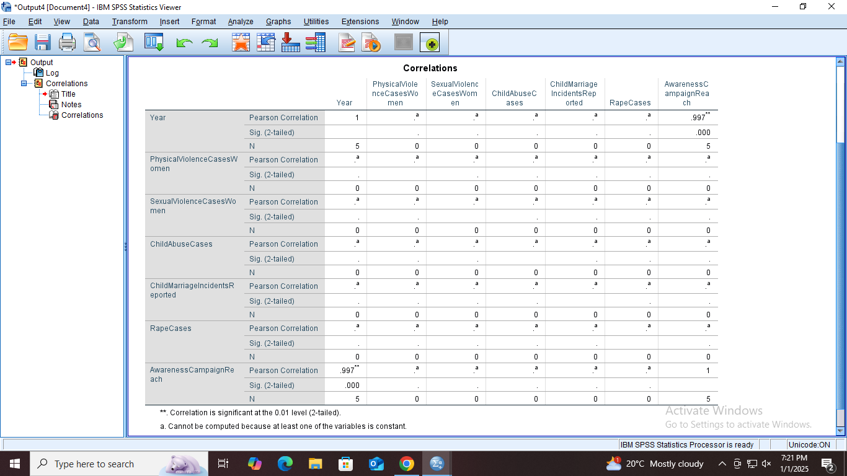

Data for this study were obtained from publicly accessible sources, including reports from the Bangladesh Bureau of Statistics (BBS), Ain o Salish Kendra (ASK), BRAC, UNICEF, and national media outlets such as Prothom Alo and The Daily Star. The study focused on key variables, including physical and sexual violence cases among women, child abuse, child marriage incidents, reported rape cases, and the reach of awareness campaigns. Statistical analysis was employed to examine yearly changes in these variables from 2018 to 2022, assessing percentage variations and correlations with the reach of awareness campaigns. Additionally, the study compared regional differences to identify areas facing significant challenges in addressing and reducing violence.